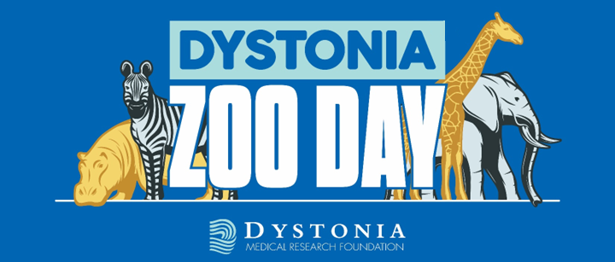

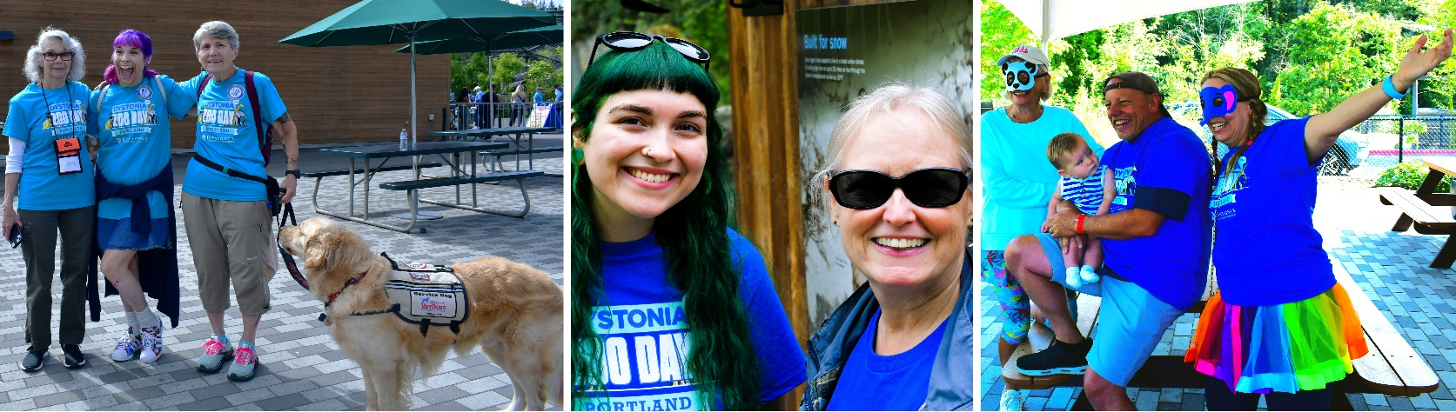
Portland Dystonia Zoo Day
Join friends of the Dystonia Medical Research Foundation (DMRF) for the 2025 Portland Dystonia Zoo Day.
This is a family-friendly event to raise awareness of dystonia, a little-known brain disorder, and to support the important work of the DMRF to find a CURE!

July 26, 2025
9:00 AM Registration & T-shirt pick-up Opens
Event begins at 10:30 am in the Polar Plaza

Cost: $25 Adults/$15 Children (12 and under)

Oregon Zoo
4001 SW Canyon Road, Portland, OR 97221

