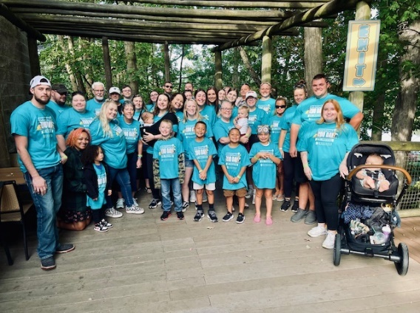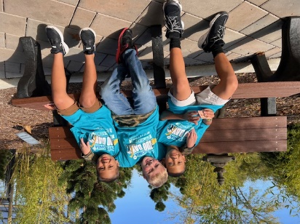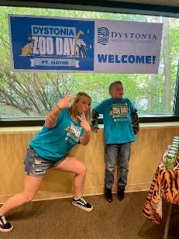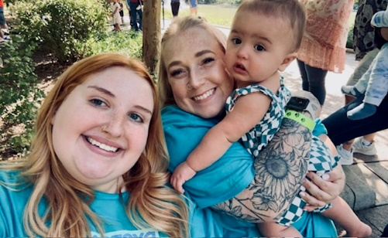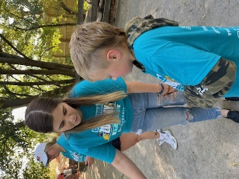

**The Dystonia Medical Research Foundation invites you to join us as a sponsor of   
2025 Fort Wayne Dystonia Zoo Day!**

**This event is a wonderful opportunity for you to demonstrate your leadership in helping to bring awareness to a cause that is often overlooked.**

**What is Dystonia?**

Dystonia is a brain disorder that causes extreme muscle spasms so intense they produce involuntary movements and postures of the body and limbs. Gait, balance, speech, and vision may be impaired due to the twisting, painful contortions. Put quite simply, people with dystonia cannot control the movement of their own bodies. The disorder affects people of all ages and backgrounds.

**What Are Dystonia Zoo Days?**

Dystonia Zoo Days are a national series of family-friendly community events that promote awareness of dystonia, connect the dystonia community, and support the work of the DMRF. These are not traditional walks, as many with dystonia are unable to walk, but are empowering events that engage individuals and families impacted by dystonia, their friends and colleagues, and the local professional community.

**How Your Support Helps**

Sponsors reach family and professional audiences in the Ft. Waynemetro areawhile partnering with the DMRF to inform the public about dystonia leading to more accurate diagnosis and offer a better path to treatment and improved patient quality of life for those struggling with dystonia.

**September 27, 2025 @ The Fort Wayne Children’s Zoo**

The Fort Wayne Dystonia Zoo Day is organized by families affected with various forms of dystonia from childhood to adult onset, they are hoping to spread awareness, educate the public, and generate donations for the DMRF. Special guests, including medical experts and members of the dystonia community will share their stories and talk about the need for improving diagnosis rates and investing in research. Learn more at **dystonia-foundation.org/FtWayne-Zoo-Day**.

**Use the QR to Register**



**dystonia-foundation.org**

**2025 Sponsorship Opportunities!**

**Register by August 1 and benefits Upgrade to next level!**

Elephant Sponsor ($5000)

Company support acknowledged in the Dystonia Dialogue magazine (circulation 55,000)

Company logo featured on event Web site + social media posts with hashtags and links as directed

Company logo featured on pre and post event promotional materials

Exhibit-information table for handing out information during the event

Company prominently featured on event signage & t-shirts

FREE admission for a “team” of 10 participants – includes personalized team t-shirts

Giraffe Sponsor ($2500)

Company logo featured on event Web site and social media posts

Exhibit-information table for handing out information

Company prominently featured on event signage & t-shirts

FREE admission for a “team” of 10 participants – includes personalized team t-shirts

Rhino Sponsorship ($1000)

Company name featured on event Web site and social media post

Exhibit-information table or opportunity to provide insert in event goodie bags

Company featured as sponsor on event signage & t-shirts

FREE admission for a “team” of 8 participants

Zebra Sponsorship ($500)

Sponsor recognition on event signage and t-shirts

FREE Admission for 4 participants

Lemur Sponsorship ($250)

Sponsor recognition on event signage

FREE Admission for 2 participants

Friend Sponsorship ($100)

Sponsor recognition on event signage

In-Kind Sponsor

Donations of food, beverages, and items for the silent auction will receive recognition on signage



**dystonia-foundation.org**

**Ft. Wayne Dystonia Zoo Walk Sponsor Registration  
Deadline September 3, 2025  
Benefit Upgrades Available Until August 1!**

Company Name:

Contact First Name: Last Name:

Address:

City: State: Zip Code:

Daytime Phone:

E-mail Address:

**Type of Sponsorship (please circle the appropriate level)**

Elephant - $5000 Giraffe - $2500 Rhino - $1000 Zebra - $500 Lemur - $250 Other - $

In-Kind Sponsor of: Tickets @ $25/$15

**Method of Payment:**

○ Please send an invoice to:

○ Check payable to the DMRF ○ Visa ○ MasterCard ○ American Express ○ Discover

Account Number: Exp. Date:

Billing address (if different from above):

City: State: Zip Code:

**TEAM NAME:**

Elephant & Giraffe Sponsors – 10 FREE participants Lemur 2 FREE Participants  
Rhino Sponsors – 8 FREE participants **Individual Tickets are $25 for adults/$15 kids**  
Zebra Sponsors – 4 FREE participants

**Requested Shirt Sizes (please indicate number of shirts needed in each size):**

Adult S Adult M Adult L Adult XL Adult XXL

Youth S Youth M

Please fax this form to 312-803-0138 or mail to:   
**DMRF, One East Wacker Drive, Suite 1730, Chicago, IL 60601  
DMRF is a 501c3 organization. Tax ID: 95-3378526**

**Register Online:** [**www.dystonia-foundation.org/Indy-Zoo-Day**](http://www.dystonia-foundation.org/Indy-Zoo-Day)



**dystonia-foundation.org**

**Thank you for your support.**



**dystonia-foundation.org**