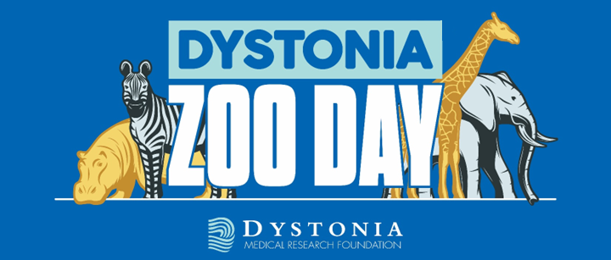

Become a Sponsor
New England Dystonia Zoo Day
June 14, 2025
Demonstrate your leadership and bring awareness to a rare disorder.
What is Dystonia?
Dystonia is a brain disorder that causes involuntary muscle spasms, producing abnormal movements and postures of the body and limbs. Gait, balance, speech, and vision may be impaired due to the often painful contortions. Dystonia affects people of all ages and backgrounds.
What Are Dystonia Zoo Days?
Dystonia Zoo Days are a national series of family-friendly community events that promote awareness of dystonia, connect the dystonia community, and support the work of the DMRF. These are not traditional walks, as many with dystonia are unable to walk, but are empowering events that engage individuals and families impacted by dystonia, their friends and colleagues, and the local professional community.
How Your Support Helps
Your sponsorship reaches family and professional audiences in the Providence/Boston metro areas, informing the public about dystonia, supporting the advancement of dystonia research, and connecting patients and families to programs of support.
June 14, 2025 @ The Rogers Williams Zoo, Providence, RI
The New England Dystonia Zoo Day is organized by families affected with various forms of dystonia from childhood to adult onset. They are hoping to spread awareness, educate the public, and generate donations for the DMRF. Special guests, including medical experts and members of the dystonia community will share their stories and talk about the need for improving diagnosis rates and investing in research. Learn more at dystonia-foundation.org
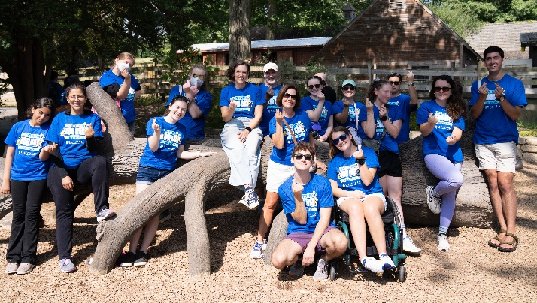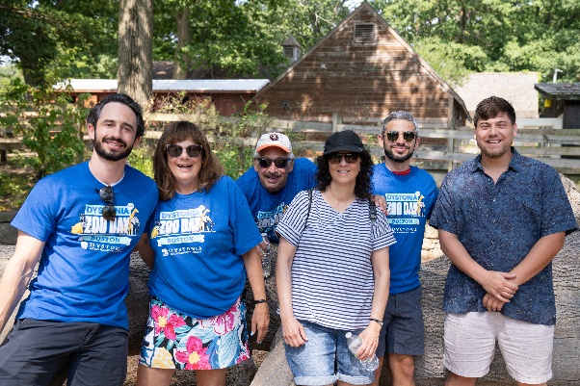
2025 Sponsorship Opportunities!
New England Dystonia Zoo Day
June 14, 2025
Register by May 5 and benefits Upgrade to next level!

Elephant Sponsor ($5000)
Company support acknowledged in the Dystonia Dialogue magazine (circulation 55,000)
Company logo featured on event website + social media posts with hashtags and links as directed
Company logo featured on pre and post event promotional materials
Information table provided during event
Company prominently featured on event signage & t-shirts
FREE admission for a “team” of 10 participants – includes personalized team t-shirts

Giraffe Sponsor ($2500)
Company logo featured on event website and social media post
Information table provided during event
Company prominently featured on event signage & t-shirts
FREE admission for a “team” of 10 participants – includes personalized team t-shirts

Rhino Sponsorship ($1000)
Company name featured on event website and social media post
Exhibit-information table or opportunity to provide insert in event goodie bags
Company featured as sponsor on event signage & t-shirts
FREE admission for a “team” of 8 participants

Zebra Sponsorship ($500)
Company featured as sponsor on event signage and t-shirts
FREE Admission for 4 participants

Lemur Sponsorship ($250)
Sponsor recognition on event signage
FREE Admission for 2 participants

New England Dystonia Zoo Day Sponsor Registration
Deadline May 28, 2025
New & Returning Sponsors that register by May 5th will be upgraded to the next level!
Company Name:
Contact First Name: Last Name:
Address:
City: State: Zip Code:
Daytime Phone:
E-mail Address:
Type of Sponsorship (please circle the appropriate level)
Elephant - $5000 Giraffe - $2500 Rhino - $1000 Zebra - $500 Lemur - $250 Other - $
In-Kind Sponsor of:
Method of Payment:
○ Please send an invoice to:
○ Check payable to the DMRF ○ Visa ○ MasterCard ○ American Express ○ Discover
Account Number: Exp. Date:
Billing address (if different from above):
City: State: Zip Code:
TEAM NAME:
Elephant & Giraffe Sponsors – 10 FREE participants
Rhino Sponsors – 8 FREE participants
Zebra Sponsors – 4 FREE participants
Requested Shirt Sizes (please indicate number of shirts needed in each size):
Adult S Adult M Adult L Adult XL Adult XXL
Youth S Youth M
Please fax this form to 312-803-0138 or mail to:
DMRF, One East Wacker Drive, Suite 1730, Chicago, IL 60601
DMRF is a 501c3 organization. Tax ID: 95-3378526
Register Online: www.dystonia-foundation.org
Thank you for your support.

